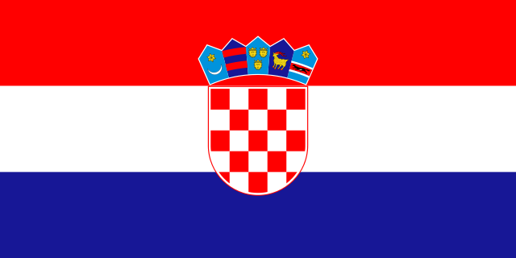
Croatia Quiz
for TANDEM European Union Day Edition
Your name and e-mail address:
1. What is the Capital city of Croatia?
Zagreb or Ljubljana
2. Which neighboring country has the longest border with Croatia?
Hungary or Bosnia-Herzegovina
3. What kind of animal was named after the Croatian coastline?
A dog or a cat
4. What is the currency of Croatia called?
dinar or kuna
5. What was the result for the Croatian football team in the Euro 2012?
Fall out in the quarter-finals or 3rd place in the group matches
6. In which national park of Croatia was made the German-Yugoslavian coproduction western film “Treasure of the Silver Lake”?
Plitvice Lakes or Brijuni islands
7. How many letters are in the Croatian alphabet?
More than in the Polish alphabet or less than in the Polish alphabet
8. Which parent of the legendary leader of Yugoslavia, Josip Broz “Tito” was Croatian?
The father or the mother
9. Who is currently the prime minister of Croatia?
Ivo Josipović or Zoran Milanović
10. According to CIA Factbook, how many people live in Croatia? TIP

